* CB FSD - Integration and Deployment

Day 6 : 19 July 2024

Building the spring boot projects.

Generally we create spring boot project using maven or gradle

In Spring boot project we need to create jar or war file.

Maven goal

mvn validate it check pom.xml file syntax

mvn clean it remove old build files or target directory

mvn compile it compile whole project and generate target folder which all .class files and build files.

mvn test it is use to test all test cases part of project

mvn package it generate jar or war file.

Creating maven project using command prompt.

mvn archetype:generate

after downloaded few jar files it ask project number.

Hit enter key : it is going to create simple project

Again hit once again.

groupId: my-project

artifactid: my-simple-maven

version :1.0

package : com

if we want to run maven goal. We need to open the terminal in the place where pom.xml file must be present.

Creating Jenkin job to build spring boot projects.

Setting maven in CI and CD tools

Manage Jenkin -🡪

Tools -🡪

Add Maven 🡪

Name 🡪 Maven

Version 🡪 3.9.2

Creating job to build node js project

Downloading Plugin

Manage Jenkin

Plugin option

Available plugin

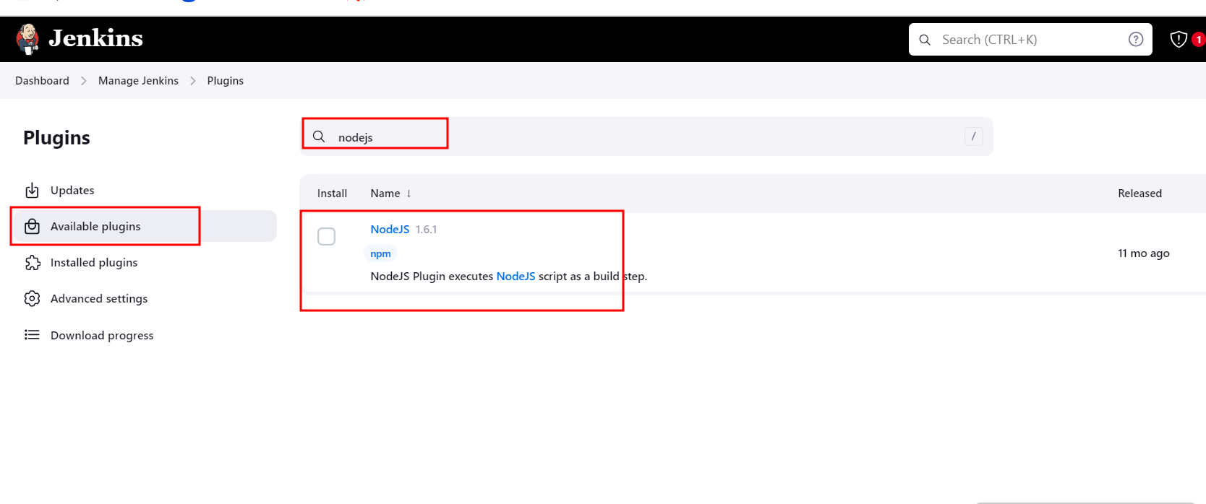

After downloaded please verify plugin installed or not in tool options.

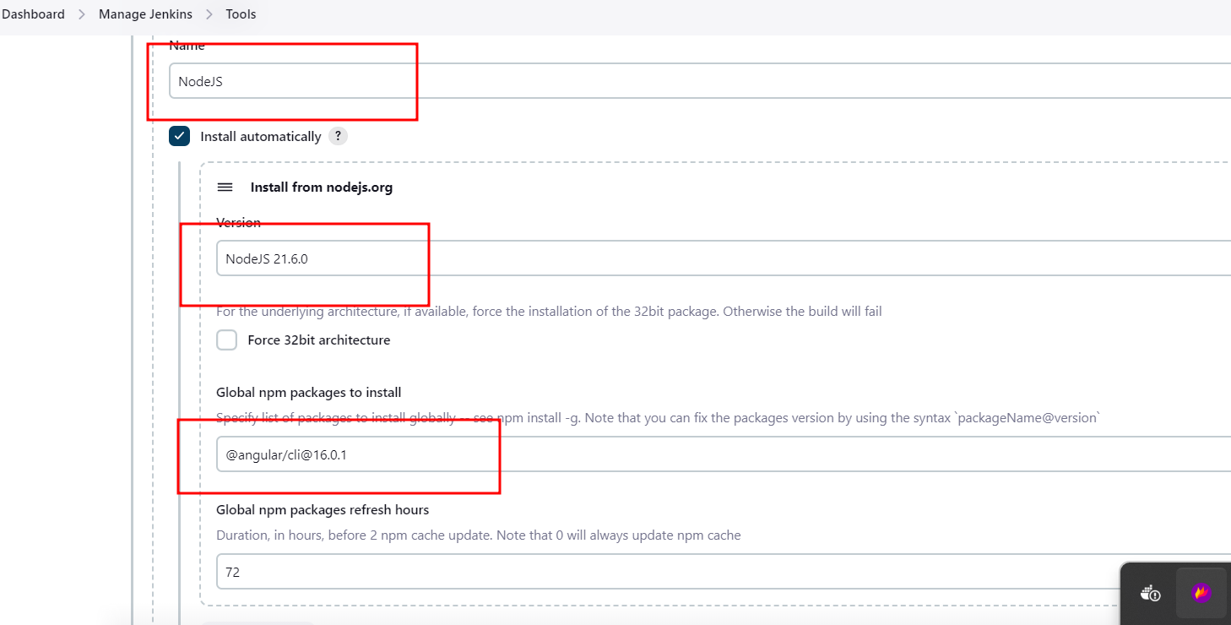

Build Node JS Project

Build Angular Project using CI and CD tool ie Jenkin

Steps.

1. Create angular project in local machine or VM machine.

ng new angular-jenkin

routing 🡪 Yes

styling 🡪 css

cd anglar-jenkin

do some changes in app.component.html page ( as a development work).

1. We need to push this code in remote repository.

git init

git add .

git commit -m “initial commit “

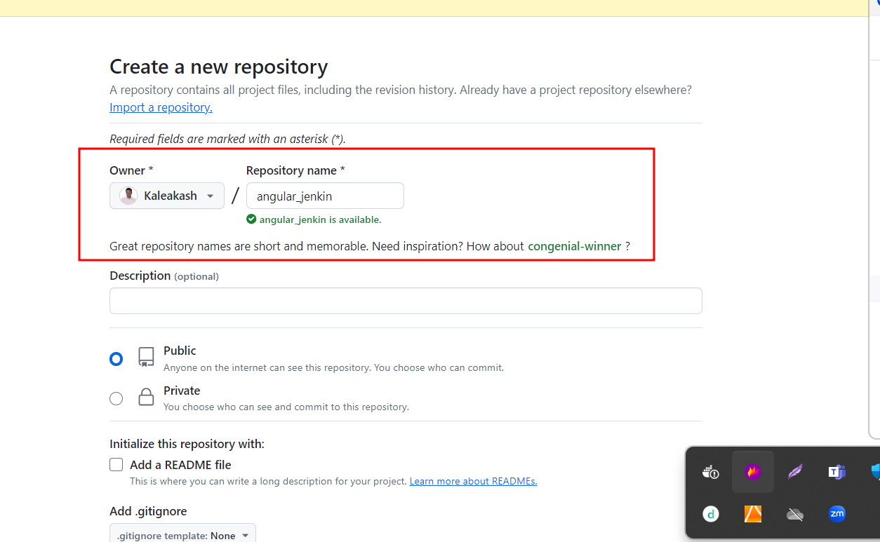

Connection local repository with remote repository using below command.

**git remote add origin https://github.com/Kaleakash/angular_jenkin.git**

now we can push the code from local to remote

git push -u origin HEAD

1. Now we create CI and CD job to build angular projects.
2. Create user defined branch and do some task like login page creation in user defined branch

git checkout -b login-app

ng g c login

do some development

git add .

git commit -m “login page created in login-app brach”